**UChicago Capstone - Automated Utility Bill and Contract Processing using Agentic RAG**

**Preliminary Tasks:**

1. **Understand and familiarize yourself with how to read a utility bill.  
   a. Learn the important components of a utility bill.**[**https://www.integrityenergy.com/blog/how-to-read-your-electricity-bill-uncover-hidden-savings/**](https://www.integrityenergy.com/blog/how-to-read-your-electricity-bill-uncover-hidden-savings/) **b. Understand potential variations in utility bills.  
   c. Learn how Power Kiosk uses information extracted from utility bills.**
2. **Understand and familiarize yourself with Power Kiosk’s contract documents.  
   a. Learn the important components of a contract document.  
   b. Understand potential variations in contract documents.  
   c. Learn how Power Kiosk uses information extracted from contract documents.**
3. **Familiarize yourself with the end goal and overall project flow.  
   a. Consider the workflow and integrations (from our platform → AI Agents → back to our platform).  
   b. Identify which information can be easily extracted and which may require further processing (e.g., mathematical calculations) to be useful.  
   c. Plan for handling poor-quality or incomplete sample utility bills or contract documents.**

**Dataset:**

* **1,170 PDF files (a mix of contracts and utility bills) from our large enterprise customers.**

**Problem:**

**A significant amount of time is spent manually reviewing utility bills and contract documents from customers. To complicate matters further, a single customer contract often includes multiple locations, each with its own utility bill. As a result, the number of bills we need to manually review can quickly become overwhelming.**

**Currently, Power Kiosk is performing this manual work for three core activities:**

1. **Filling out missing customer usage information** – This information is used as a proxy for Quarterly Business Reviews (QBRs), also referred to as Contract Savings/Performance Reports and Budget Forecasts, which we provide to our enterprise customers. This task is critical, as it directly impacts customer retention and currently takes several days to complete across all enterprise accounts.
2. **Entering new customers** – Many energy brokers use our platform to “price” their customers in hopes of finding better rates. To initiate this process, we must input key customer information such as Legal Entity Name, Service Address, Rate Class, Annual Consumption, Phone Number, Email Address, etc.—all of which can typically be found in a utility bill.
3. **Supporting miscellaneous sales activities** – Our sales team often requires details from utility bills to support conversations with both current and prospective customers. Information such as rate class, usage, supply rate, tax rate, and delivery rate is commonly needed.
4. **(Bonus) Utility Cost Calculator** – We are currently developing a cost calculator that allows customers to input a few details and receive a rough estimate of potential savings when switching to our services. Successful parsing of utility bills will allow customers to simply upload their monthly bill and instantly view projected savings—without manually entering any data.

For now, focus on points 1–3.

**Due to the wide range of use cases, we should focus on:**

1. Reliably extracting all necessary information from utility bills and contracts. This includes customer name, service address, phone number, email address, and other relevant details.
2. Reading historical usage consumption data, which is often presented in tabular or graphical formats. This is a key component of our QBRs and Budget Reports.
3. Identifying the supply rate, delivery rate, and tax rate.  
   For example, the supply rate is calculated as the total supply charge on the utility bill divided by the total usage for that month. These rates are essential for QBRs, Budget Reports, and various sales support activities.

**The following section will focus on the use case associated with our Quarterly Business Reviews (QBRs) and Budget Forecasts, as they are the most important and urgent use case of this.**

Note: Some information will not be directly used in these two reports but will still be important to extract as they will be used for some of our core activities. Please check with the project stakeholders to determine what information they would want to keep from a bill and contract document.

We manually generate two types of reports for each of our top customers and their contracts

1. Savings Report (every quarter) (QBRs)
2. Budget Report (every year-end)

A sample report for Contract Savings and another for the Budget Report can be found in the SampleReports.xlsx file. The file has been annotated to indicate the data source for each column.

In recent weeks, since most of the data is stored in the database, already displayed in various locations within our platform, or retrievable through simple queries, we have been working on creating a downloadable Excel file. This file will be flexible enough to generate the report structure, including basic information such as the customer’s name, fixed price, utility charge, and utility costs. While this will significantly reduce the time required to produce the report, some manual work will still be necessary.

For usage data, we will copy and paste values from actual receivable records or account usage history received from suppliers for each customer account. These records are stored in our dashboard. If these two primary sources of usage data are unavailable, we will use historical usage data from sample utility bills. If a sample bill is also unavailable, we will rely on forecasted usage information from contract documents. If none of these four sources provide historical usage data, our last resort will be to divide the confirmed annual usage by 12 to estimate the monthly budget forecast and contract performance report. This is the least accurate option.

In the coming weeks, the downloadable Excel file should be able to automatically compile usage data from all locations for each contract, provided the data is available in actual receivable records or account usage history. This will eliminate the need to manually add usage data from 10+ locations for each contract per customer in our dashboard, which we had been doing previously.

The main challenge arises when usage data is unavailable from our two primary and most reliable sources. In such cases, we will need to extract usage data from utility bills and contract documents, which is especially important for newer customers. Therefore, we need to extract usage from sample bills.

Additionally, to build the Budget Report, we also need tax and delivery rates, both of which are manually extracted from sample bills. Furthermore, the Sales team is currently performing a significant amount of manual work to extract account numbers, service addresses, total spend, and other details from customer bills.

**Usage Extraction Steps:**

1. Check for usage values in ‘Actual Receivables’. If available, we will use this data. Note: This information is stored in our database and displayed on our platform.

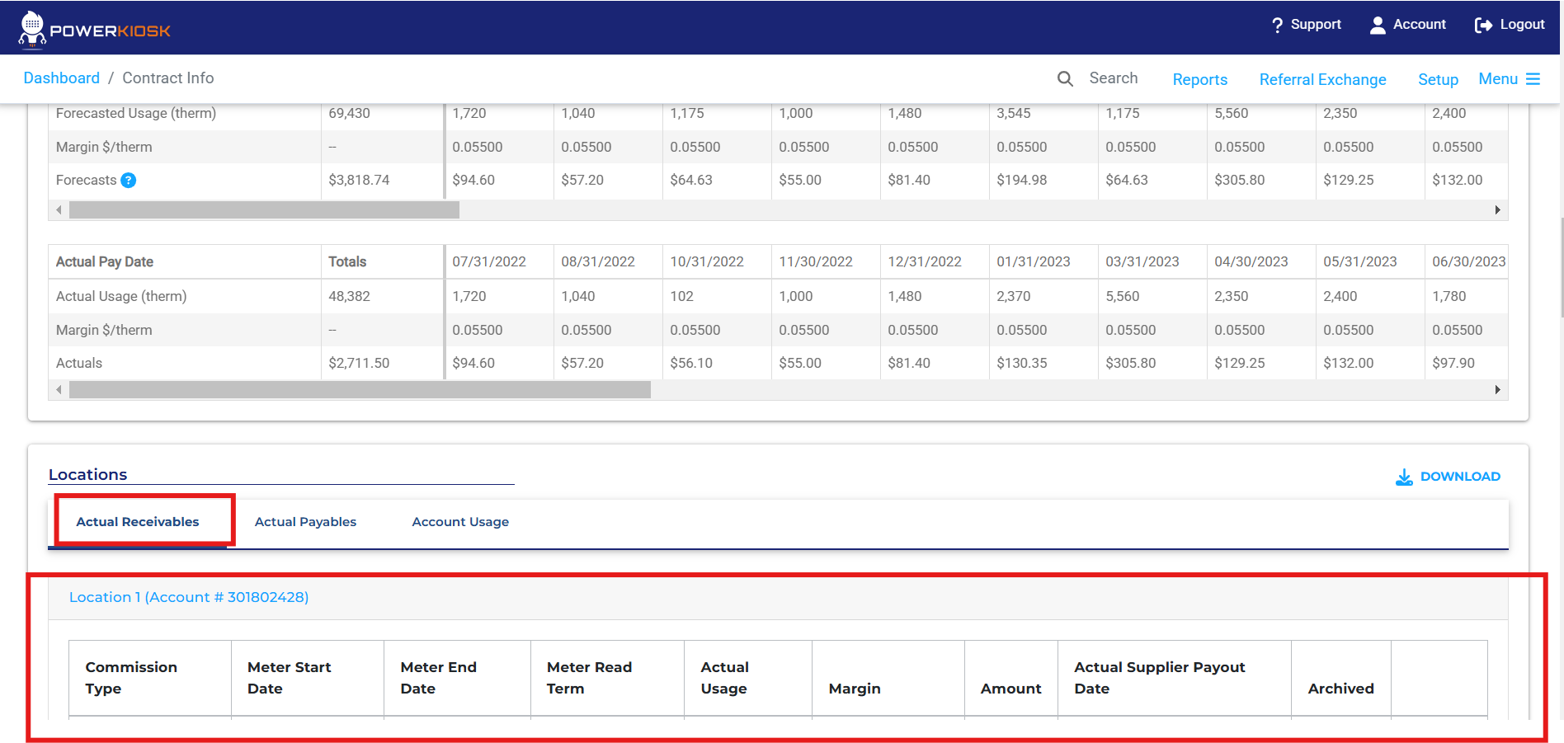

1. If not available, check for usage values in ‘Account Usage’. If available, we will use this data. Note: This information is stored in our database and displayed on our platform.

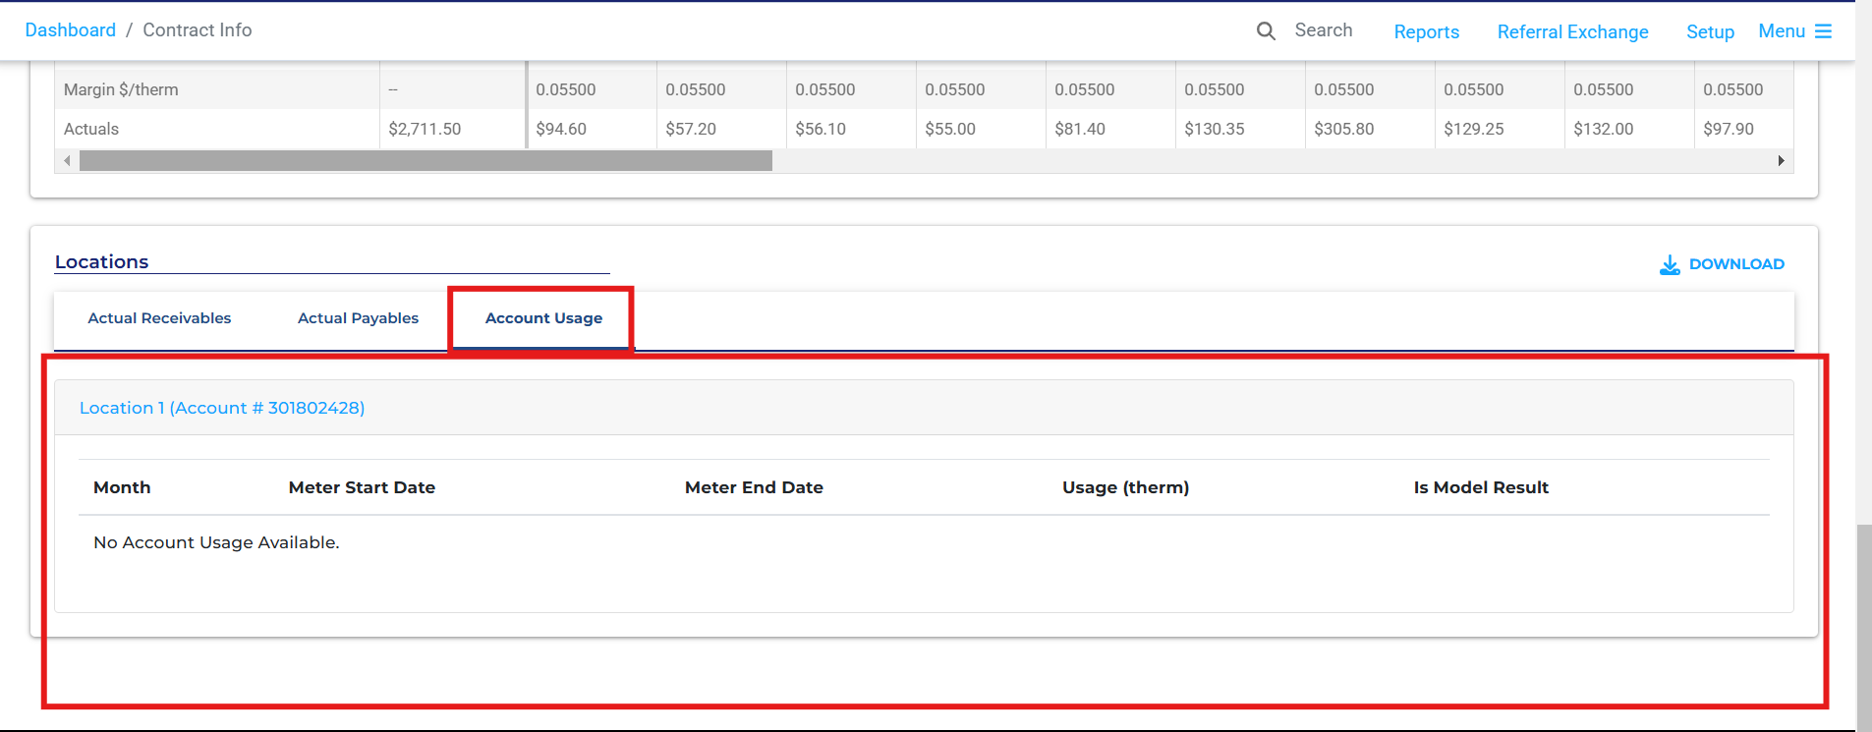

1. If usage data is still unavailable, manually inspect the ‘Notes/Task/Attachments’ tab to locate a ‘Sample Bill’ or a ‘Contract’ document.  
   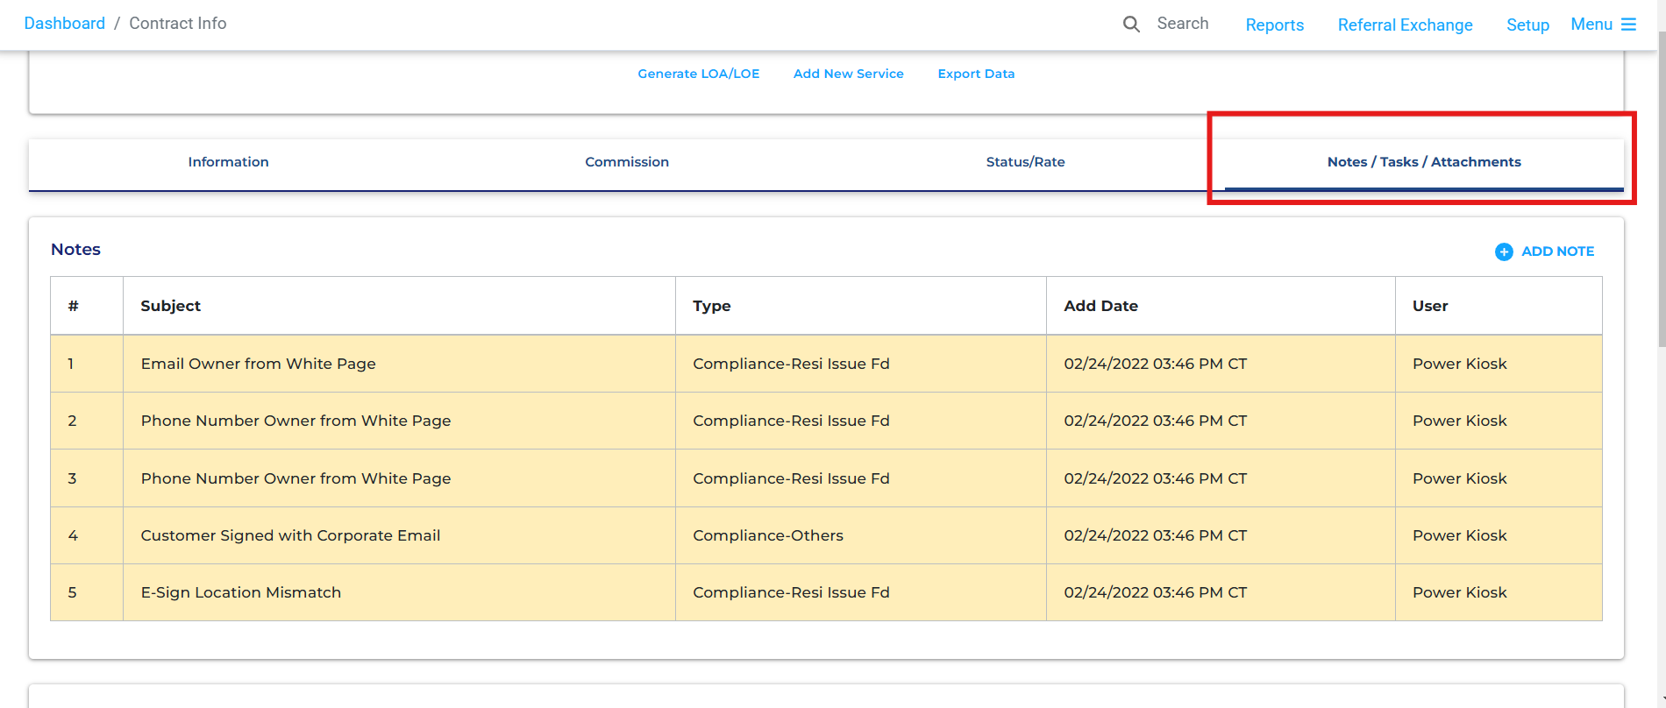

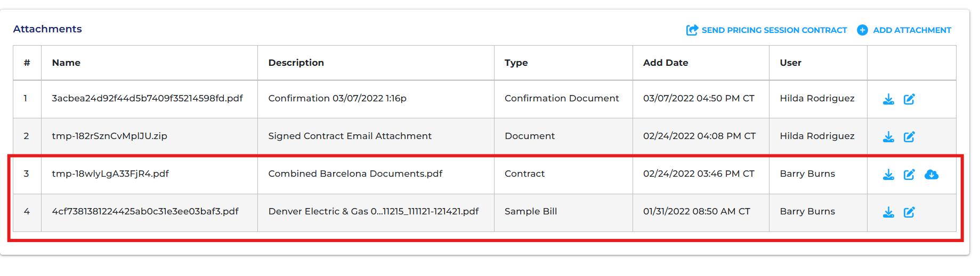

Note: The above information is stored in our database and can be retrieved through simple queries.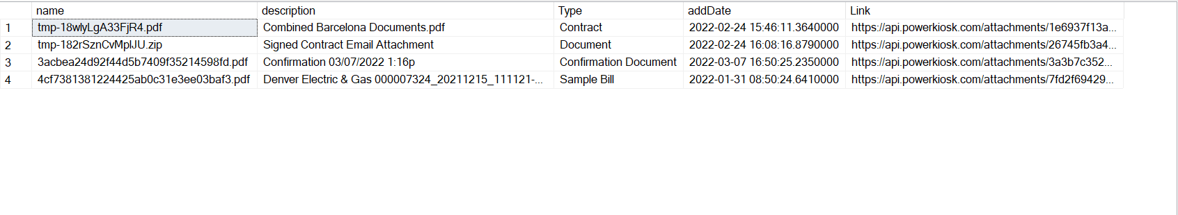

1. If a ‘Sample Bill’ is found, extract the monthly usage values from the bill (if available).

* If there are multiple contracted locations, ensure that sample bills exist for each of them.
* **Very Important:** Sample bills may be provided as separate files or aggregated into one file.

1. If a ‘Sample Bill’ is not available, open the ‘Contract’ document.

* In contract documents, usage data for all locations is always stored within a single document, if available.

1. Add the extracted usage data to the respective columns in the Excel report.

**Examples for Usage Extraction from Bills and Contract Documents for Contract Savings Report:**

**Example One (Sample Bill):**

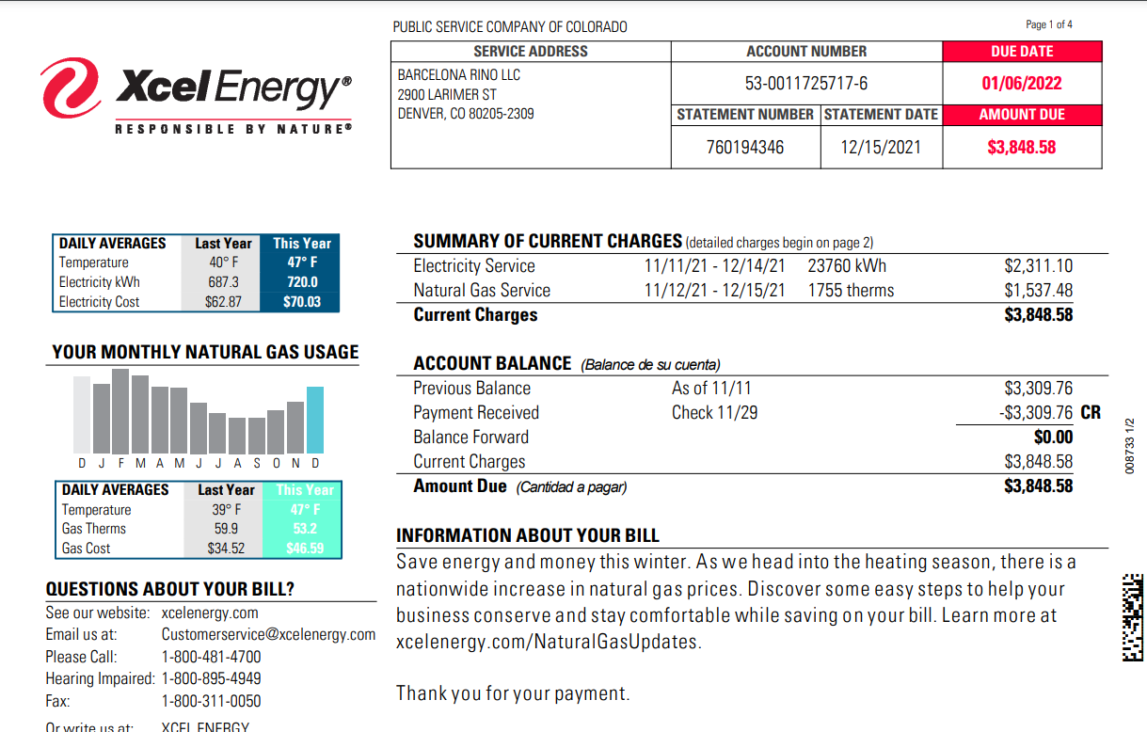

In this bill, historical usage data is stored in a bar graph; however, there are no axis labels. Therefore, we typically ignore this and refer to the contract document for the same customer.

Logic/Steps:

1. Review each page to search for a table or graph that presents a 12-month or 13-month summary of usage. The relevant section is typically found under a heading such as “Monthly Consumption”, “Consumption History”, or “Usage Summary”.

**Example One (Contract):**

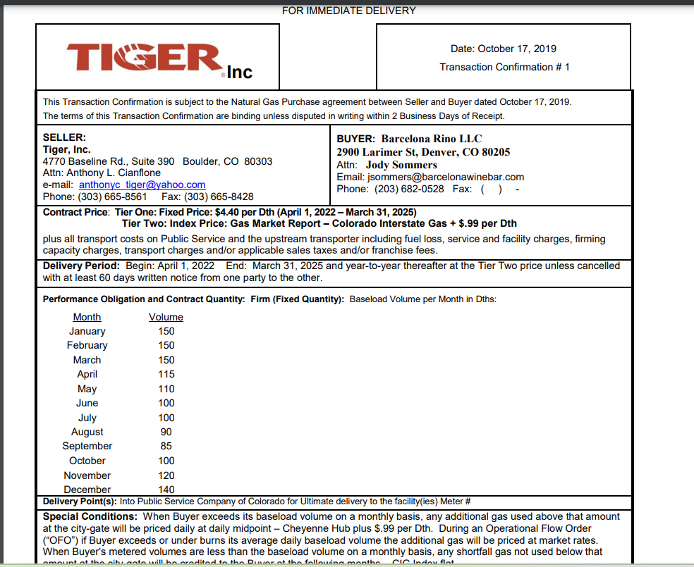

In this contract document, out of five pages, the monthly usage forecast appears on only one page (page 2). In contract documents, usage data is typically presented in a table format rather than in a graph. The only variations arise from two sources:

1. **Multiple Tables for Different Locations**: Some contract documents contain more than one table, with each table corresponding to a different service location under the same contract. In such cases, we must aggregate the data by month. In this particular case, there is only one location for this contract.
2. **Forecasted Usage Over the Contract Duration**: Some contract documents provide a monthly usage forecast for the entire contract duration. For example, if the contract period is May 2022 – May 2025, the document will present a usage forecast for each month from May 2022 to May 2025. Others, like the example above, only provide data for January – December, requiring us to use the same values for each corresponding month throughout the contract duration.

Logic/Steps:

1. Review each page to locate a table summarizing usage data. It is typically found under a heading such as “Contracted Volume” or “Performance Obligation”.
2. If multiple tables exist, aggregate the data accordingly.
3. If the year is not explicitly mentioned next to the month, look for clues regarding the contract duration.

* In the example above, a section above the usage summary specifies the delivery period (April 2022 – March 2025).

1. Record the usage data consistently.

* For instance, April 2022, April 2023, April 2024, and April 2025 will each use a value of 115.

1. Ensure the correct units are recorded. The final extracted usage data from this contract document should be structured as follows:

|  |  |
| --- | --- |
| **Month-Year** | **Volume (Dths)** |
| April-2022 | 115 |
| May-2022 | 100 |
| June-2022 | 100 |
| July-2022 | 100 |
| August-2022 | 90 |
| September-2022 | 85 |
| October-2022 | 100 |
| November-2022 | 120 |
| December-2022 | 140 |
| January-2023 | 150 |
| February-2023 | 150 |
| March-2023 | 150 |
| April-2023 | 115 |
| May-2023 | 110 |
| June-2023 | 100 |
| July-2023 | 100 |
| August-2023 | 90 |
| September-2023 | 85 |
| October-2023 | 100 |
| November-2023 | 120 |
| December-2023 | 140 |
| January-2024 | 150 |
| February-2024 | 150 |
| March-2024 | 150 |
| April-2024 | 115 |
| May-2024 | 110 |
| June-2024 | 100 |
| July-2024 | 100 |
| August-2024 | 90 |
| September-2024 | 85 |
| October-2024 | 100 |
| November-2024 | 120 |
| December-2024 | 140 |
| January-2025 | 150 |
| February-2025 | 150 |
| March-2025 | 150 |

1. Our plan is to store these values in our database so that they can be displayed on our dashboard. The data available on our dashboard will then be downloadable as an Excel file.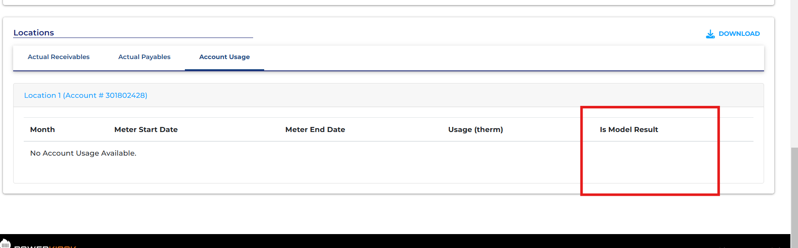

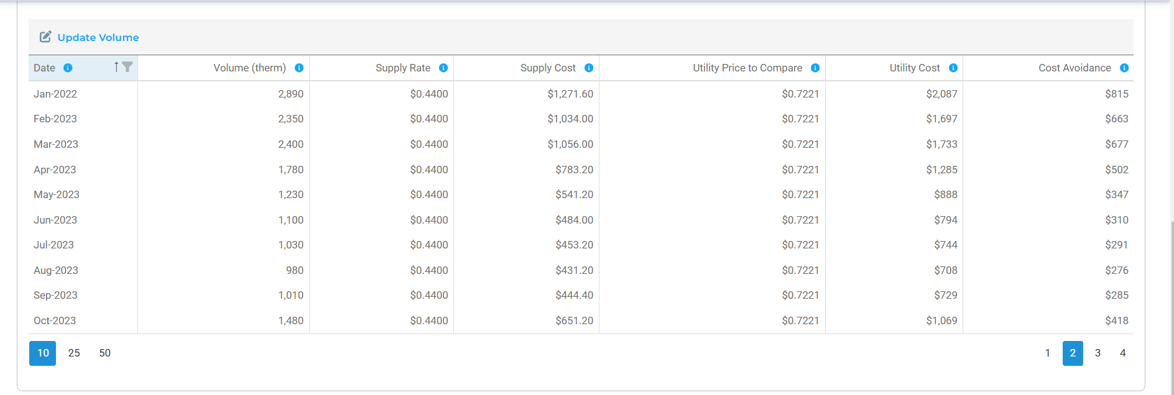

Note: Currently we have the same Excel report displayed in our dashboard. We are working to add a download button to then convert whatever is being shown here into the report in Excel. Usage, if not available in our actual receivables or account usage tabs, will be extracted manually. Other columns of the report, such as Supply Rate, Supply Costs, Utility Price to Compare, Utility Cost , and Cost avoidance don’t require manual work.

**Example Two (Sample Bill):**

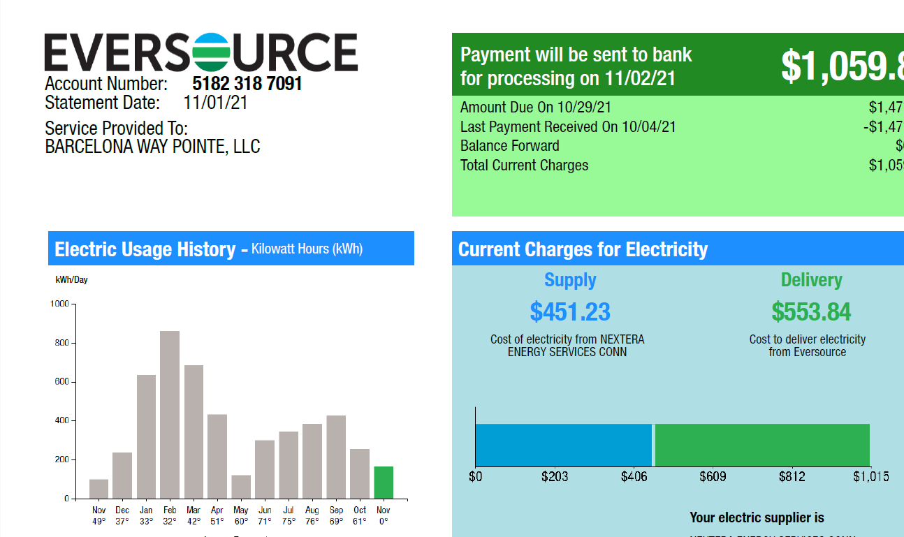

Things to check before reading Sample Bill

1. Check the number of locations under this contract in our dashboard. In this case, there is only one location, so one Sample Bill file will be sufficient and we can expect to see one usage summary table or graph inside the Sample Bill.

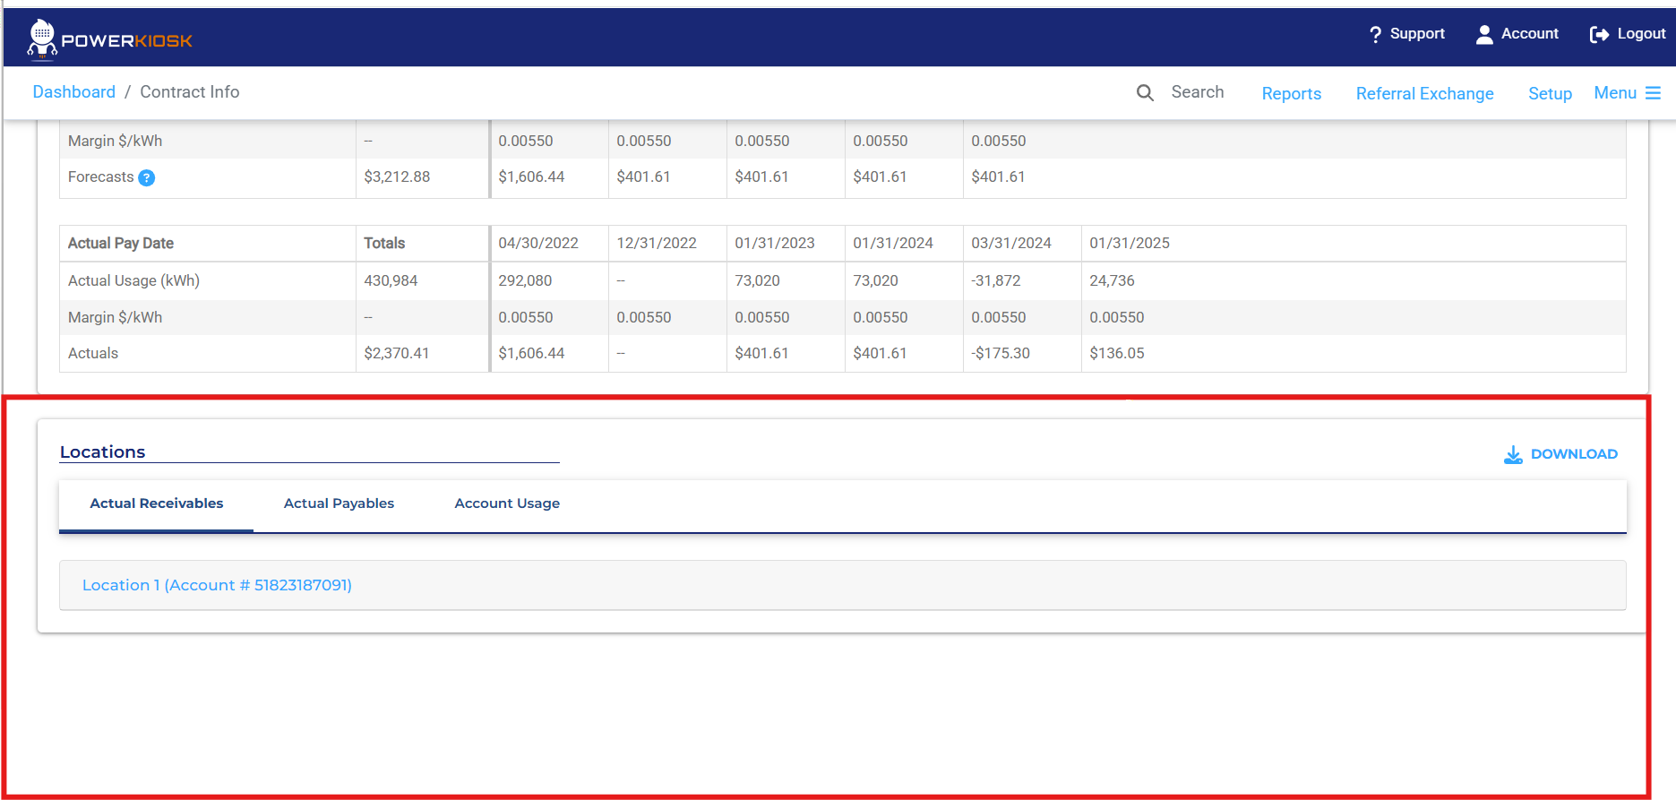

1. Check for usage data in ‘Actual Receivables’ and ‘Account Usage’.

* In this example, no usage data is available from suppliers or any receivable payments from the customer. Therefore, we need to use the usage summary from the Sample Bill.

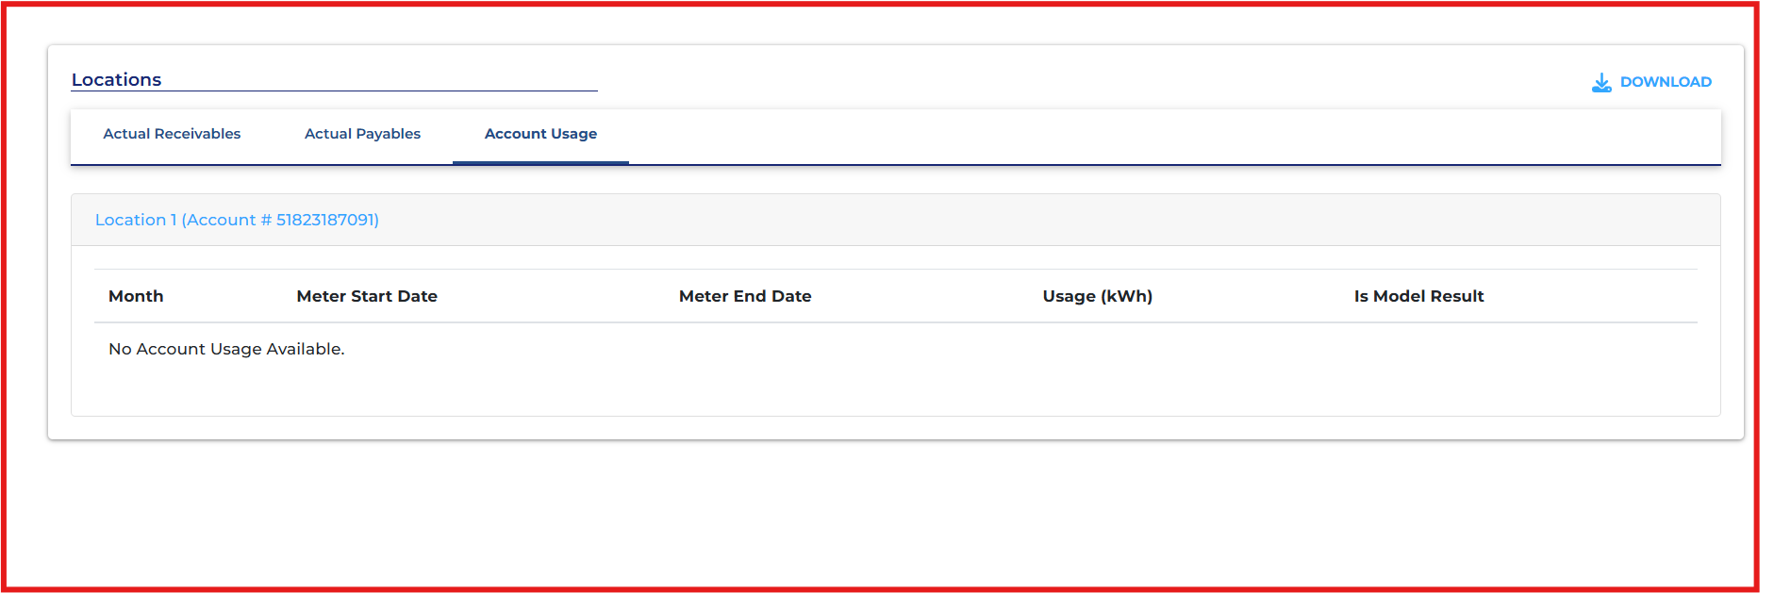

Steps/Logic:

1. Check for a 12-month or 13-month usage summary table or graph on each page.
2. The first page contains a graph with a label saying, “Electric Usage History”. However, the y-axis is labeled "kWh/day", and the x-axis is labeled "Average Temperature". We can estimate values by multiplying by 30/31 to get a monthly estimate, but this is not the best approach since a better usage summary is available on the second page.
3. The second page contains a table labeled “Monthly kWh Use”, which is easier to read and already provides calculated values for each month. Hence, we should use this.

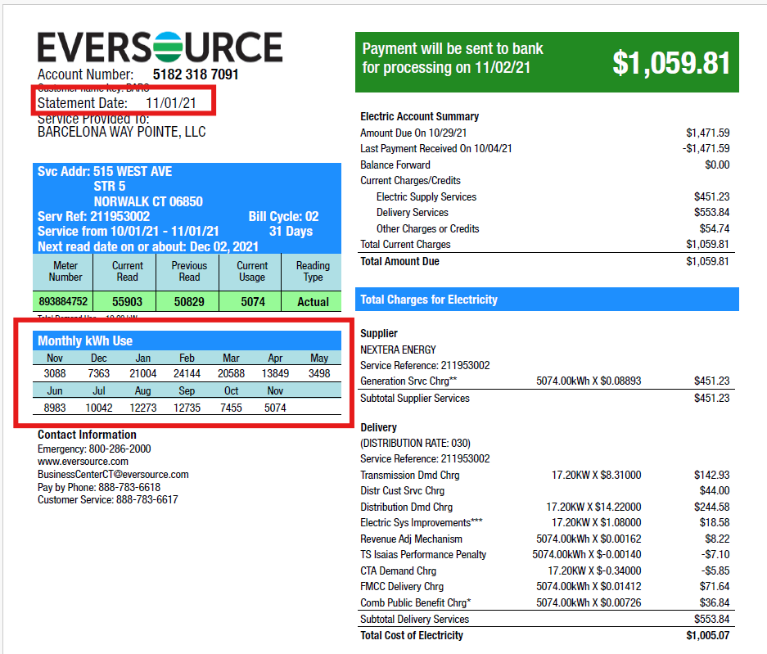

1. Note: Page three contains two additional graphs labeled "Supply Rate" and "Demand Profile". These do not provide the required data and should be ignored.
2. Extract the values from the correct usage summary table (second page)

* Since the months are listed without a year, we must determine the corresponding years.
* This can be inferred by checking statements such as:
  + “Payment will be sent to the bank for processing on 11/02/21”
  + “Statement Date: 11/01/2021”
* **Example:**
* The rightmost value for November (5074) corresponds to November 2021.
* The leftmost value for November (3088) corresponds to November 2020.

1. The right extracted usage values from the table, with the right year, should look as follows:

|  |  |
| --- | --- |
| **Month-Year** | **Volume (kWh)** |
| Nov-2020 | 3088 |
| Dec-2020 | 7363 |
| Jan-2021 | 21004 |
| Feb-2021 | 24144 |
| Mar-2021 | 20588 |
| Apr-2021 | 13849 |
| May-2021 | 3498 |
| Jun-2021 | 8983 |
| July-2021 | 10042 |
| Aug-2021 | 12273 |
| Sep-2021 | 12735 |
| Oct-2021 | 7455 |
| Nov-2021 | 5074 |

1. Extend the extracted values up to 2025 using the most recent data.

* Once we have these values, we will use the most recent values for each month to fill in the usages up until 2025.
* Hence, we will use the usages from Dec 2020 – November 2021 to fill in the usages in the report up until the most current date.
  + February 2025 will use February 2021’s value.
  + December 2024 will use December 2020’s value.
  + November 2024 will use November 2021’s value.
* This logic is already being implemented in our dashboard, so our focus remains on extracting the correct usage values and sending them to our system for storage and future use.

**Example 2 (Contract):**

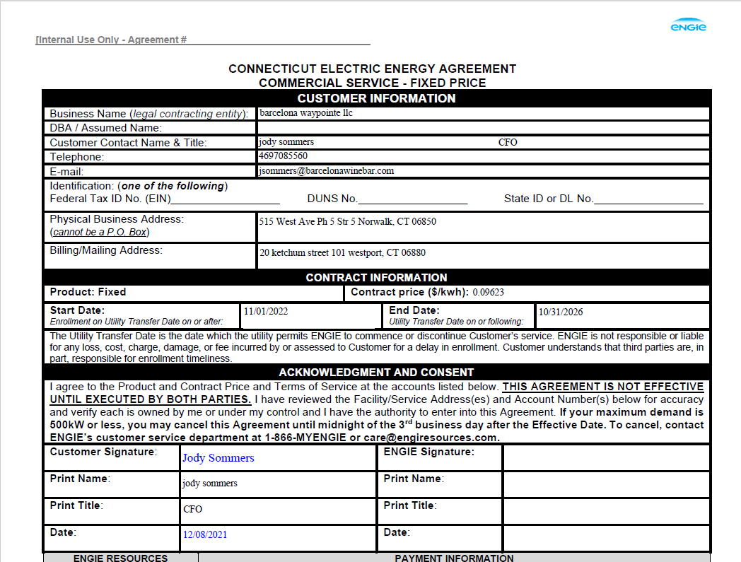

Since we found usage data from the Sample Bill for this contract, we do not need to inspect the Contract document. However, for demonstration purposes, the Contract document contains a total of nine pages. Upon review, none of the pages provide forecasted usage data.

Therefore, if historical usage data was not available from the Sample Bill, inspecting the Contract document would also be fruitless. In such cases, we use the confirmed annual usage from the contract, divided by 12, to obtain a constant monthly value.

**Example 3 (Sample Bill):**

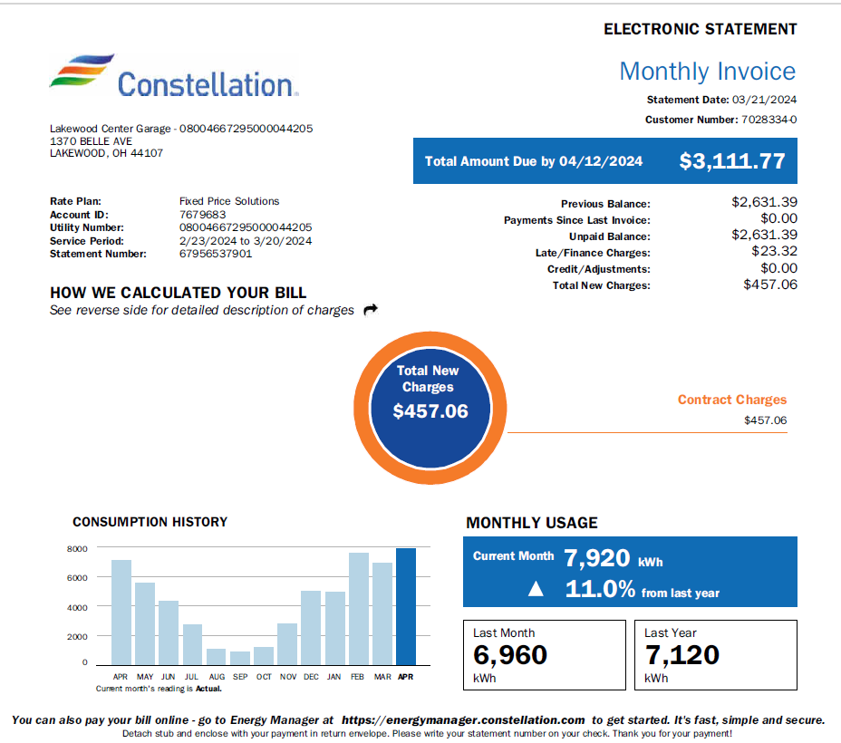

In this example, the historical usage data is found only on the first page of a four-page bill, presented as a bar graph. Since the values are not explicitly labeled, we need to estimate them.

Steps/Logic:

1. Review each page to find either a 12-month or 13-month summary of usage data.
2. Since usage data is stored as a bar graph, estimate the values for each month using clues provided throughout the bill.
3. Identify a clue regarding the year associated with each month in the graph.

* For example, the statement "Total Amount Due By 04/12/2024" suggests that the rightmost value in the graph corresponds to April 2024, while the leftmost value corresponds to April 2023.

1. Note: For instance, the bill also contains a Statement Date: 03/21/2024. Although the months do not align perfectly, we can infer that the rightmost value for April is in 2024, not 2025 or 2023.
2. Find additional clues from the bill regarding actual usage values. Here, we are given the values for the ‘Current Month”.

* The "Current Month" usage value is 7920, corresponding to April 2024.
* The "Last Month" value is 6960, meaning March 2024 in the graph corresponds to 6960.
* The "Last Year" value is 7120, indicating April 2023's usage was 7120.
* For the remaining months, we have to estimate the values.

1. This is an example of what the values might be:

|  |  |
| --- | --- |
| **Month-Year** | **Volume (kWh)** |
| April-2023 | 7120 |
| May-2023 | 5500 |
| Jun-2023 | 4250 |
| Jul-2023 | 2500 |
| Aug-2023 | 1000 |
| Sep-2023 | 900 |
| Oct-2023 | 1100 |
| Nov-2023 | 2900 |
| Dec-2023 | 5000 |
| Jan-2024 | 4950 |
| Feb-2024 | 7500 |
| Mar-2024 | 6960 |
| Apr-2024 | 7920 |

**Example 3 (Contract)**

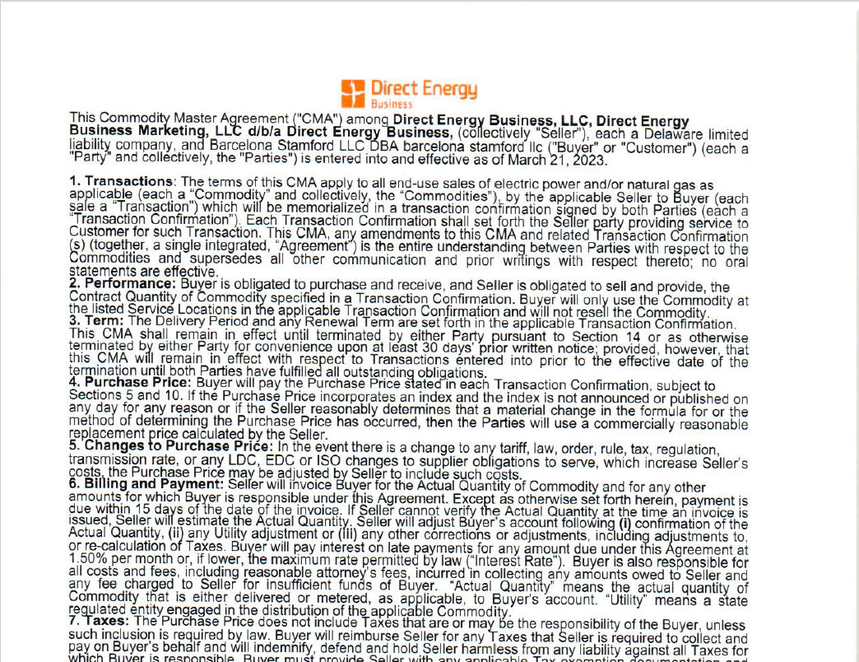

Unlike the previous two examples, this contract is not for the same customer as the Sample Bill above. However, it illustrates another type of variation that we may encounter in a Contract document.

Steps/Logic:

1. Check the number of locations under the contract. Since the customer has only one location, we do not need to search for multiple usage forecasts in this document.
2. Inspect each page to locate the usage summary.
3. Out of seven pages, the usage forecast is found only on page 7.
4. Verify whether the year is listed next to each month.In this case, it is, so we can extract the data directly.
5. Extract the relevant usage data.  
   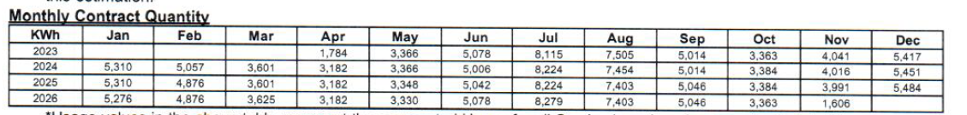

Here, usage data spans from April 2023 to November 2026, covering the entire contract duration. This represents a more straightforward method of extracting usage data from a Contract document.

**Example 4 (Sample Bill)**

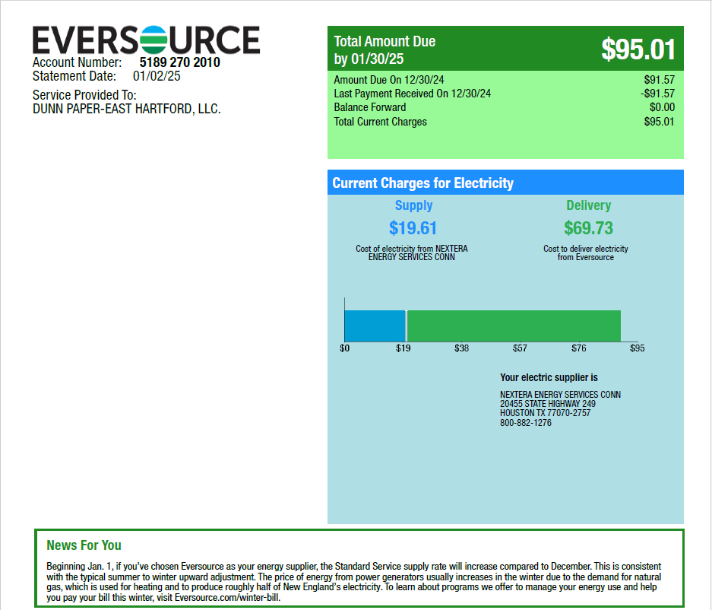

This is yet another variety that we might face in sample bills: One account number, multiple service reference numbers.

Steps/Logic:

1. Look for 12-month or 13-month usage summaries on each page.
2. Since this bill contains three usage summaries, we must sum them up.
3. Determine the correct year by analyzing clues within the bill.

* Here, we find:
  + "Total Amount Due by 01/30/2025"
  + "Statement Date: 01/02/2025"
* However, the tables list data from December to December.
* Therefore, the rightmost value for December must correspond to December 2024, while the leftmost value must correspond to December 2023.

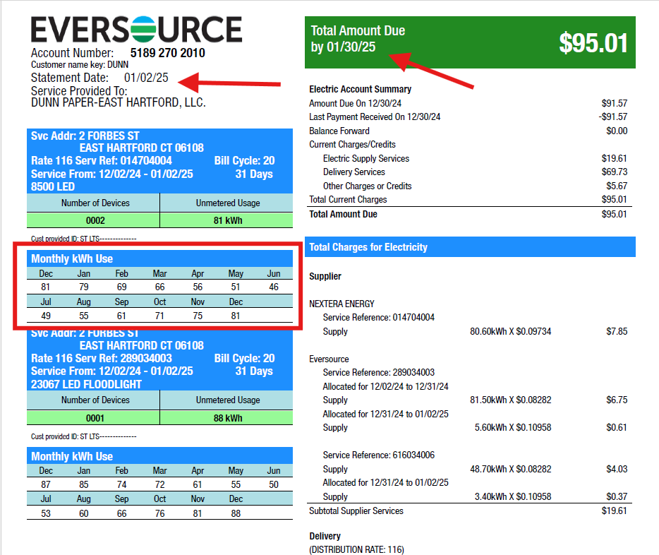

1. Extract and aggregate the usage values from all three tables.

|  |  |
| --- | --- |
| **Month-Year** | **Volume (kWh)** |
| Dec-2023 | 81+87+53 = 221 |
| Jan-2024 | 79+85+51 = 215 |
| Feb-2024 | 69+74+45 = 188 |
| Mar-2024 | 66+72+43 = 181 |
| Apr-2024 | 56+61+36 = 153 |
| May-2024 | 51+55+33 = 139 |
| Jun-2024 | 46+50+30 = 126 |
| Jul-2024 | 49+53+32 = 134 |
| Aug-2024 | 55+60+36 = 151 |
| Sep-2024 | 61+66+39 = 166 |
| Oct-2024 | 71+76+46 = 193 |
| Nov-2024 | 75+81+49 = 205 |
| Dec-2024 | 81+88+53 = 222 |

**Example 4 (Contract Document)**

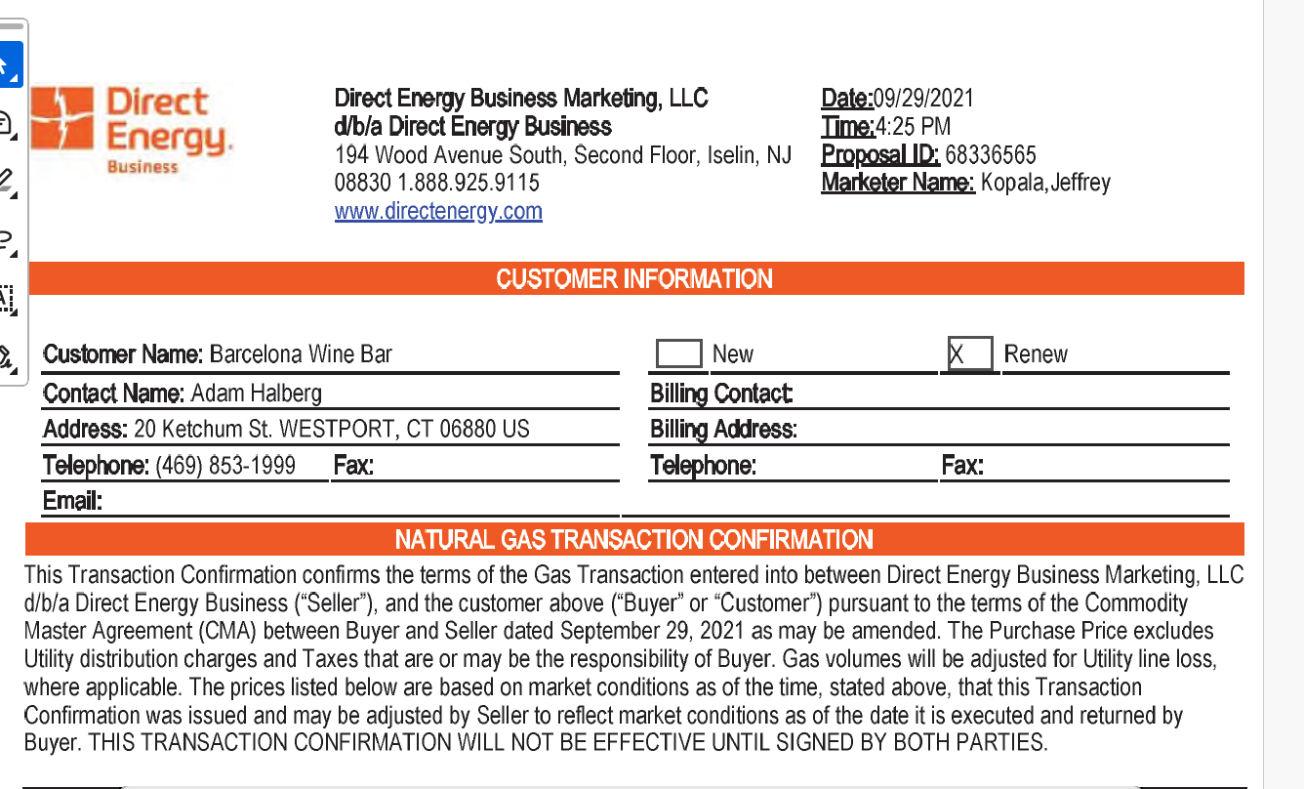

This contract is not for the same customer as the Sample Bill above (Example 4), but it presents another variation of forecasted usage data that we may encounter in a Contract document. In this case, the customer has six locations.

1. Review each page to locate a usage forecast table.
2. Aggregate all usage tables based on month.

* Note: Although there are six locations, this does not necessarily mean that there will be six separate tables.
* Sometimes, the data is aggregated into one table, while in other cases, it varies.
* In this example, there are four different usage tables.

1. Identify the correct year if it is not explicitly provided.

* Here, we find a clue in the "Delivery Period", which spans from February 2022 – January 2026.



1. Determine whether the usage values are presented on a monthly or daily basis.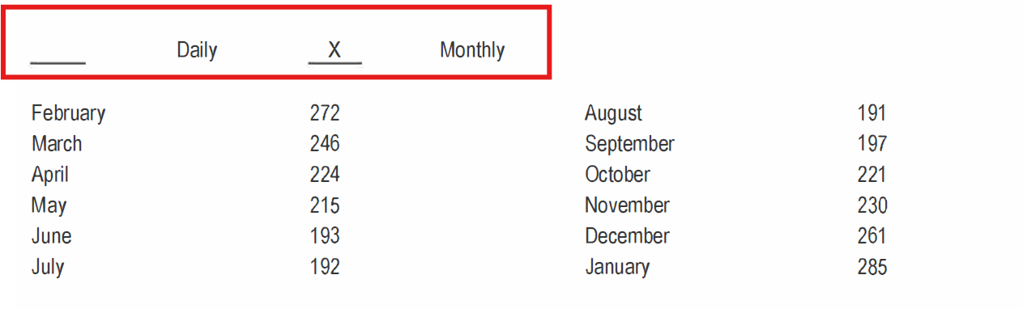
2. Extract and aggregate the usage values from all three tables:

|  |  |
| --- | --- |
| **Month-Year** | **Volume (MMBTU)** |
| February (2022-2025) | 272+336+120+207 = 935 |
| March (2022-2025) | 246+257+113+177 = 793 |
| April (2022-2025) | 224+216+103+128 = 671 |
| May (2022-2025) | 215+79+96+115 = 505 |
| June (2022-2025) | 193+53+87+88 = 421 |
| July (2022-2025) | 192+49+85+83 = 409 |
| August (2022-2025) | 191+49+79+79 = 398 |
| September (2022-2025) | 197+57+87+88 = 429 |
| October (2022-2025) | 221+149+98+121 = 589 |
| November (2022-2025) | 230 + 241 + 109 + 136 = 716 |
| December (2022-2025) | 261+330+117+187 = 895 |
| January (2022-2026) | 285+354+128+225 = 992 |

**Example 7 (Sample Bill)**

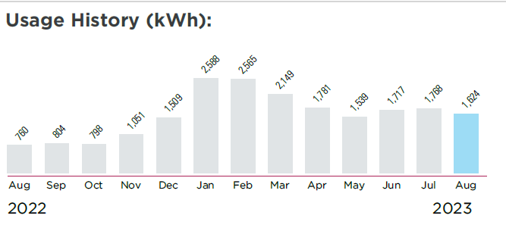

This is another example of a variation we might encounter. In this case, the data is presented in a bar graph; however, both the year and usage values are properly annotated. Therefore, the extracted usage should be:

|  |  |
| --- | --- |
| **Month-Year** | **Volume(kWh)** |
| Aug 2022 | 760 |
| Sep 2022 | 804 |
| Oct 2022 | 798 |
| Nov 2022 | 1051 |
| Dec 2022 | 1509 |
| January 2023 | 2588 |
| February 2023 | 2565 |
| March 2023 | 2149 |
| April 2023 | 1781 |
| May 2023 | 1539 |
| June 2023 | 1717 |
| July 2023 | 1768 |
| August 2023 | 1624 |

**Examples for Tax & Delivery rates extraction from Bills Budget Report:**

For ‘Budget Report’ (look at ‘SampleReports.xlsx’ for an example), aside from usages, we also need to extract delivery and tax rates. Delivery and Tax rates can only be found in a Sample Bill and not a Contract document. Moreover, if there are multiple locations, all we care about is just one delivery rate and one tax rate. We will use that as a proxy every month. Hence, if there are 5 sample bills attached for 5 locations, we only need to really look at one sample bill to get the delivery and tax rate. Usages are extracted in the same way as the ‘Contract Savings Report’. Delivery rate is taken from the total cost of delivery divided by the usage for that month. Tax rate is taken from the total cost of delivery divided by the usage for that month.

**Example 2 (Sample Bill)**

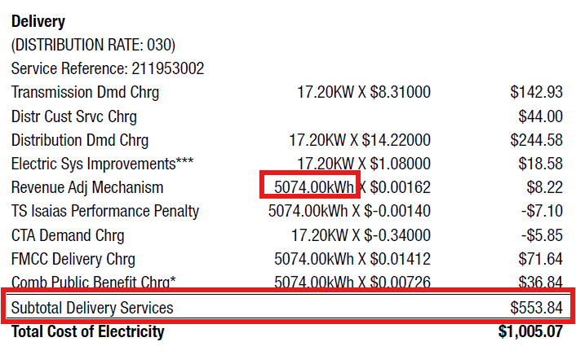

Using the same Sample Bill from Example 2, we can extract the Delivery Rate by dividing the Subtotal Delivery Services by the usage for that month, which in this case is 5074. This results in a Delivery Rate of approximately 0.1092.

Similarly, we can determine the Tax Rate by dividing the total tax charge by the same usage value (5074), resulting in a Tax Rate of 0.010788.

In most cases, if not explicitly stated, the Tax Charge will be categorized under "Other Charges." As long as the subtotal of the inline items above or below the heading contains some form of tax charge, we can confidently determine the total tax charge. In this example, we see “CT Sales Tax After Exemption,” “CT Sales Tax Supplier,” and “CT Sales Tax Delivery,” confirming that this is the total tax charge.

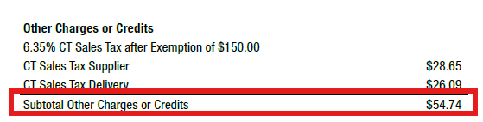

Logic/Steps:

1. To determine the correct usage for a given month, one approach is to identify the largest value next to the unit kWh. In this case, we see two numbers: 17.20 and 5074. Since 5074 is significantly larger than 17.20, in 99% of cases, the larger number represents the correct usage. The smaller number is usually just an additional fee on a small portion of the total usage
2. Alternatively, we can locate the current month's usage under the heading “Current Usage” to determine the denominator:

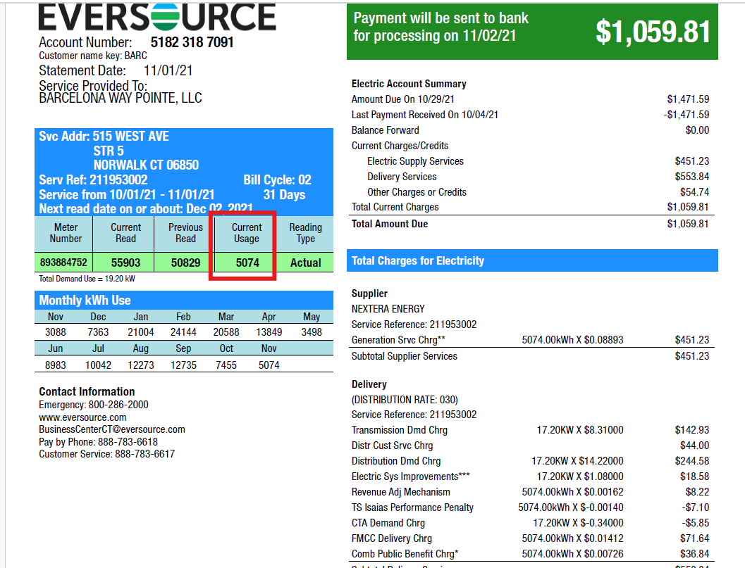

**Example 5 (Sample Bill)**

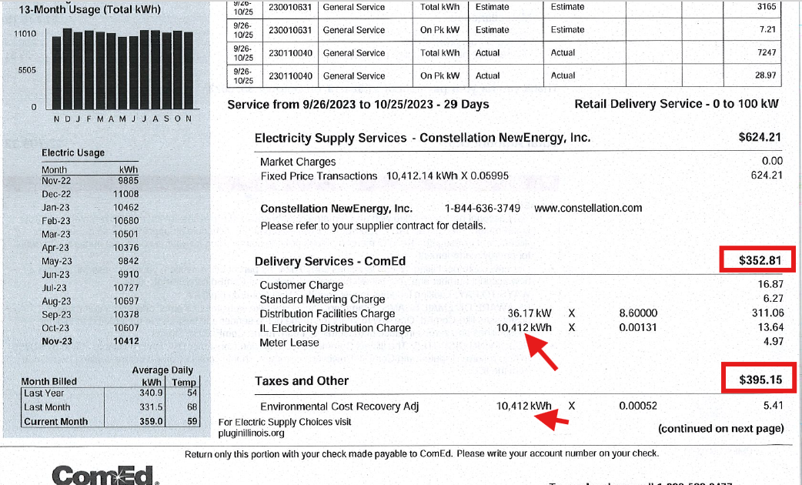

In this example, the Delivery rate will be 352.81/10,412 = 0.033885

The tax rate will be 395.15/10,412 = 0.03795

**Example 6 (Sample Bill)**

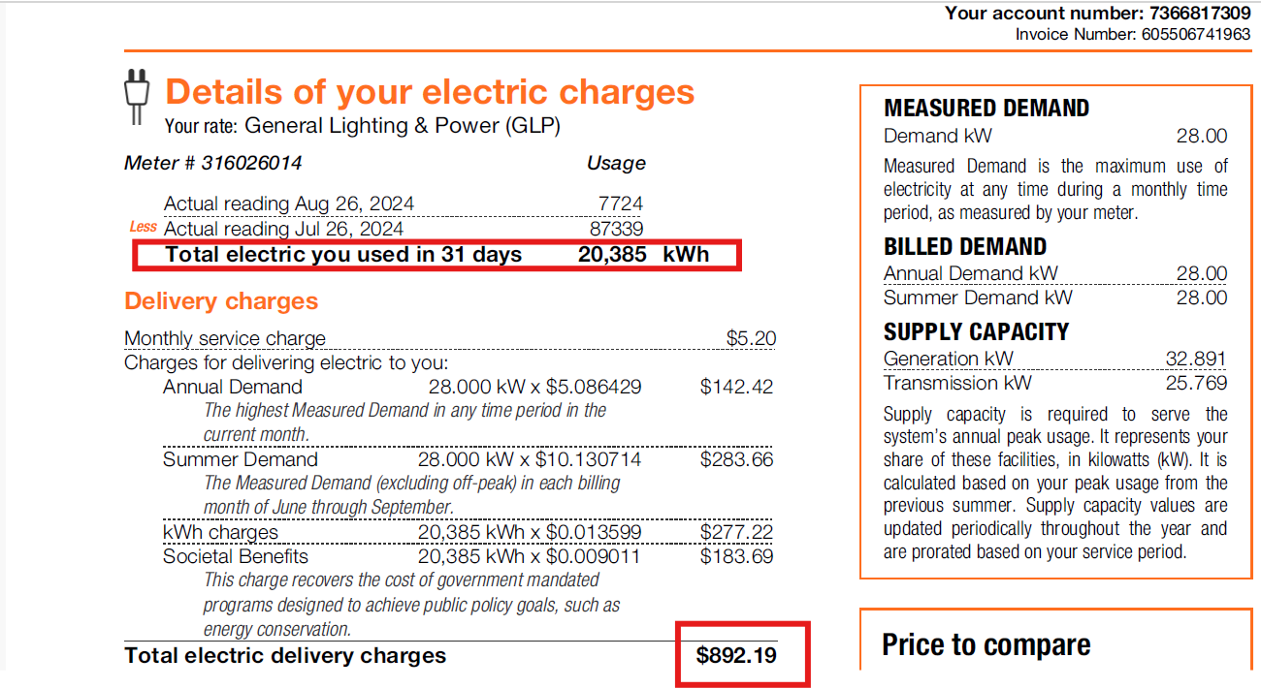

This example illustrates a scenario we might encounter. In this case, the bill provides only the Supply Charge and Delivery Charge, but no Tax Charge is listed. While this is uncommon, we should still extract the Delivery Rate using the same method.

* In this case, the Delivery Rate is calculated as 892.19 ÷ 20,385 = 0.043767.
* The usage value is listed under the heading "Total electric you used in 31 days."

Notice that our simple rule applies here as well—20,385 is significantly larger than 28.000.

Therefore, when multiple numbers appear under "Delivery Charge," it is usually reasonable to assume that 20,385 (the larger number) represents the correct usage for the month.

**Example 7 (Sample Bill)**

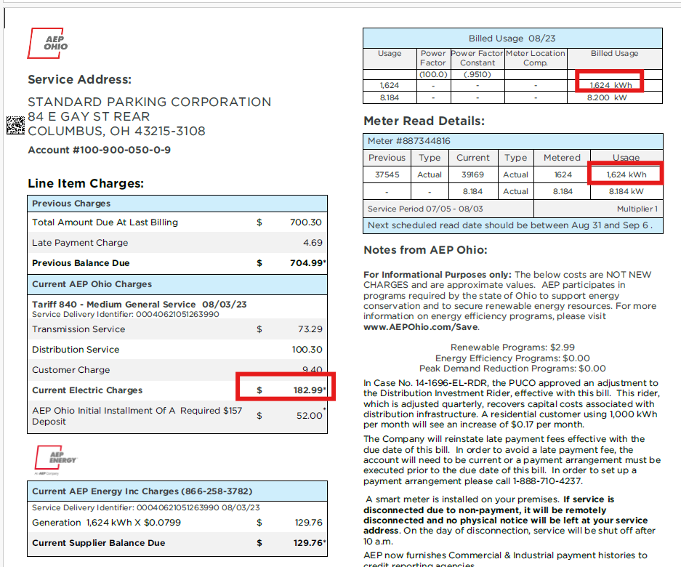

This bill also provides another example where tax charges are not listed. Additionally, the Delivery Charge is not explicitly labeled, making it less obvious.

One clue is the line item labeled "Distribution Service," which strongly suggests that this subtotal represents a Delivery Charge rather than a Supply Charge.

Another clue can be found on the first page of the bill, which includes an illustration breaking down the total charge components.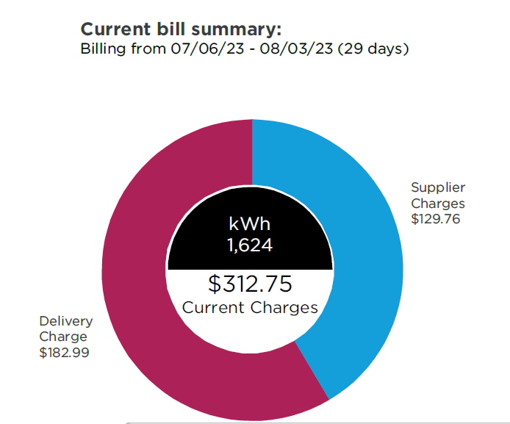

From this illustration, we can also see the actual kWh usage values, which we can use as the denominator.

Aside from the illustration, the actual kWh usage is also listed under "Meter Read Details."

* However, the bill also provides kW values, which should not be used.

The correct value to extract is the one labeled in kWh (refer to the red highlight above).

The delivery rate here is 0.11268.

**Example 8 (Sample Bill)**

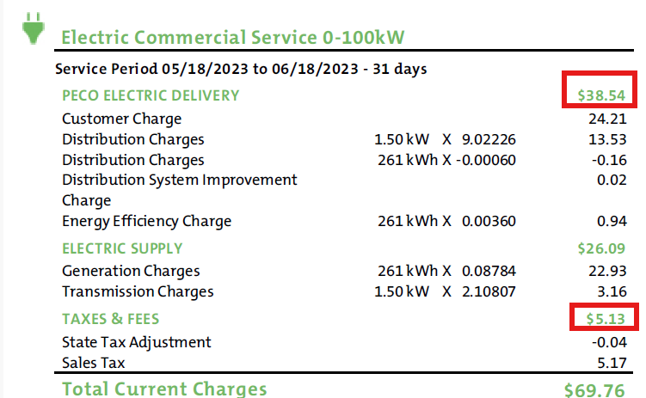

Here, the delivery rate is 38.54/261 = 0.14766

The Tax rate is 5.13/261 = 0.01966

The supply rate, although not used in the report, is also valuable information for Sales and sometimes OPS. In this bill, it is 26.09/261 = 0.099962

**The following section will focus on the general use case of the information typically found in a utility bill or contract. These will be useful for our other core activities (e.g. entering a new customer or miscellaneous sales activities).**

**General logic/steps when reading through Contract:**

The ones highlighted in yellow are the necessary information we need to build the reports, while the rest are some good to have information extracted from Contracts.

So far, we have described the process based on use cases for both the Contract Savings Report and the Budget Report. From this section onward, we will follow a similar approach, but instead of focusing on specific use cases, we will review all the important information needed for each document (Sample Bill and Contract), regardless of the context.

Although we are primarily using this information to create reports, other teams within Power Kiosk, such as Sales and Operations, could also benefit from the information found in bills. Since some of the information that Sales and Operations manually search for is also currently being used to verify logic when extracting usage data or finding rates (e.g., using the statement date to determine the appropriate year, identifying the number of unique service reference numbers/locations, and analyzing delivery and tax charges), it might be beneficial to extract and store this information as well.

The ones highlighted in yellow are the necessary information we need to build the reports, while the rest are good to have information extracted from Bills.

**General logic/steps when reading through Sample Bills:**

**Information to Extract:**

1. 12-month or 13-month historical usage
2. Delivery Charge & Rate
3. Tax Charge & Rate
4. Supply Charge & Rate
5. Current Month’s actual usage
6. Statement Date or “Amount due by” or Invoice Date or Issue Date
7. Service Address(es)
8. Customer DBA Name
9. Account Number(s)
10. Meter Number(s)
11. Rate Class
12. Unit (kWh, Therms, CCF, MMBTU)

Steps:

1. Go through each page individually.
2. Inspect the number of unique account numbers. If there is more than one unique account number, multiple usage summaries may be present.
3. Look for a 12-month or 13-month usage summary on each page.

* This can be in the form of a horizontal or vertical table or a bar chart (labeled or unlabeled).
* If the bar chart does not contain actual values, estimate the usage data using the axis labels.

1. If a bill contains multiple usage summaries, aggregate them by month.
2. If the usage summary does not specify a year, infer the year by referencing the Statement Date, "Amount Due By" date, Invoice Date, or Issue Date.

* If the month in the historical usage summary matches the bill's month, the corresponding year is straightforward.
* If the months do not align exactly, apply additional logic to determine the correct year.
* Example: If the statement date is February 2025, but the historical usage summary's most recent month is December, then December 2024 should be used, not December 2025.
* General Rule: If historical usage month > statement date month, it likely belongs to the previous year.

1. Identify the Total Delivery Charge by looking for a subtotal value under or next to the heading "Delivery Charge."
2. Identify the Total Tax Charge by looking for a subtotal value under or next to the heading "Tax Charge."
3. Identify the Total Supply Charge by looking for a subtotal value under or next to the heading "Supply Charge."
4. Determine the current month’s actual usage from one of the following sources:

* The section labeled "Actual Usage" or "Meter Read Details" in the bill.
* The rightmost month in the usage history (for horizontal tables) or the last month in the usage history (for vertical tables).

1. Calculate the respective rates for Delivery, Tax, and Supply by dividing the Total Delivery Charge, Total Tax Charge, and Total Supply Charge by the current month’s actual usage.

* Note: Not all bills will contain all three charges:
* Some bills may only include the Supply Charge.
* Others may have only the Delivery and Tax Charges.
* Some may contain only Delivery and Supply Charges.

1. Extract the service address from the section labeled "Service Address", which is present in nearly every bill.
2. Extract the account number from the section labeled "Account Number."
3. Extract the meter number from the section labeled "Meter Number."
4. Extract the rate class, which will be found:

* Under or next to the heading "Rate Class."
* Explicitly written as a range (e.g., "0 – 100 kWh" or "0 to 100 kWh").
* Next to category labels such as “General Lighting & Power (GLP),” “Retail Delivery Service,” or “Electric Commercial Service.”

1. Determine the correct unit of measurement.

* If the bill includes kWh, it pertains to electricity.
* If the bill includes MMBTU, all usage values should be assumed to be in MMBTU.
* Gas bills typically use MMBTU, Therms, or CCF.
* It is rare for a bill to contain multiple units of measurement in different sections.

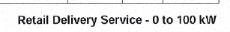

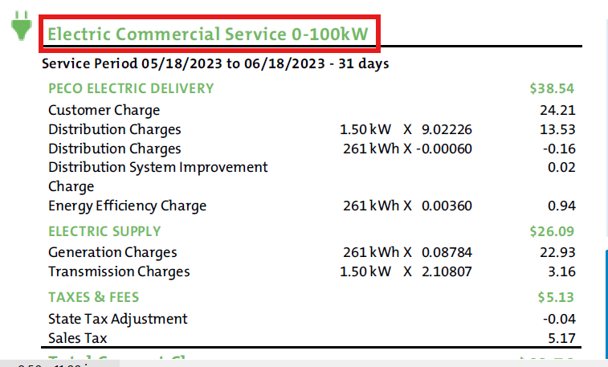

**General logic/steps when reading through Contract:**

The ones highlighted in yellow are the necessary information we need to build the reports, while the rest are some good to have information extracted from Contracts.

**Information to Extract:**

1. 12-month forecasted usage or entire contract forecasted usage
2. Delivery Period or Contract Duration or Contracted Period or Effective Dates
3. Service Address(es)
4. Customer DBA Name
5. Account Number(s)
6. Meter Number(s)
7. Rate Class
8. Rate(s)
9. Unit (kWh, Therms, CCF, MMBTU)

Steps:

1. Go through each page individually.
2. Inspect the number of unique account numbers.

* If there is more than one unique account number, multiple usage forecasts may be expected.

1. Look at each page for a 12-month forecast or a monthly forecast that spans the entire contract duration.
2. If the year is not listed, find clues using the delivery period.
3. Extract the service address, which will always be located beneath or next to a heading labeled "Service Address" in almost every bill.
4. Extract the account number, which will always be located beneath or next to a heading labeled "Account Number."
5. Extract the meter number, which will always be located beneath or next to a heading labeled "Meter Number."
6. Extract the rate class, which may appear:

* Beneath or next to a heading labeled "Rate Class."
* Explicitly as a range (e.g., "0 – 100 kWh" or "0 to 100 kWh").
* Next to category labels such as "General Lighting & Power (GLP)," "Retail Delivery Service," or "Electric Commercial Service."

1. Extract the contracted rate, which is usually written in the form of $/kWh, $/Therm, or in cents.

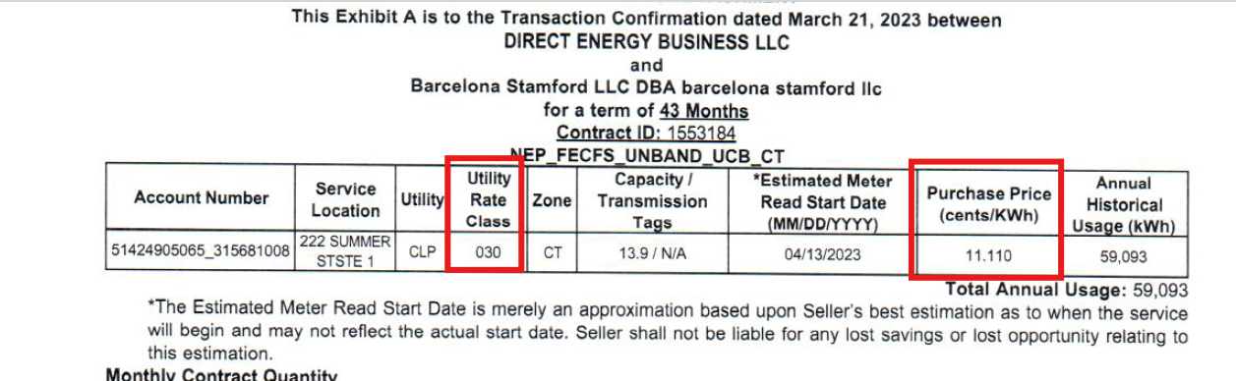

1. Determine the correct unit of measurement.

* If the bill contains “kWh”, it likely pertains to electricity. Otherwise, it is likely gas.
* If the bill uses MMBTU, all usage values should be assumed to be in MMBTU.
* If the bill uses kWh, all usage values should be assumed to be in kWh.
* If the bill uses Dth, all usage values should be assumed to be in Dth.
* It is rare for a bill to contain multiple units of measurement in different sections.

**Full Sample Bill Extraction Examples:**

**Example 2 (Sample Bill):**

1. 12-month or 13-month historical usage

|  |  |
| --- | --- |
| **Month-Year** | **Usage (kWh)** |
| Nov 2020 | 3088 |
| Dec 2020 | 7363 |
| Jan 2021 | 21004 |
| Feb 2021 | 24144 |
| Mar 2021 | 20588 |
| Apr 2021 | 13849 |
| May 2021 | 3498 |
| Jun 2021 | 8983 |
| Jul 2021 | 10042 |
| Aug 2021 | 12273 |
| Sep 2021 | 12735 |
| Oct 2021 | 7455 |
| Nov 2021 | 5074 |

Source:

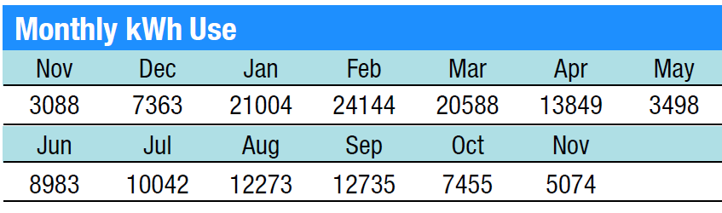

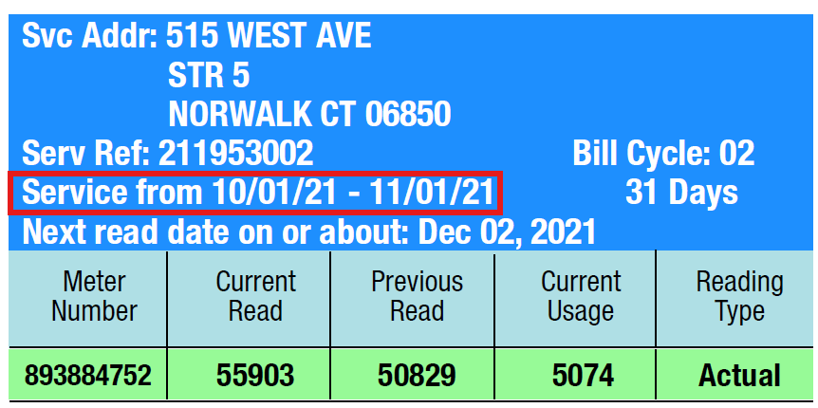

1. Delivery Charge & Rate

**Subtotal Delivery Services: $1,005.07**

Current Usage: 5074

**Delivery Rate: $0.19808**

1. Tax Charge & Rate

**Subtotal Other Charges or Credits: $54.74**

Current Usage: 5074

**Tax Rate: $0.010788**

1. Supply Charge & Rate

**Subtotal Supplier Services: $451.23**

Current Usage: 5074

**Supply Rate: $0.0889298**

1. Current Month’s actual usage

**Current Usage: 5074**

1. Statement Date or “Amount due by” or Invoice Date or Issue Date

**11/01/21**

1. Service Address(es)

**BARCELONA WAY POINTE, LLC**

**STE 101**

**20 KETCHUM ST**

**WESTPORT CT 06880-5939**

**Source (Usually at the top or bottom of a page):**

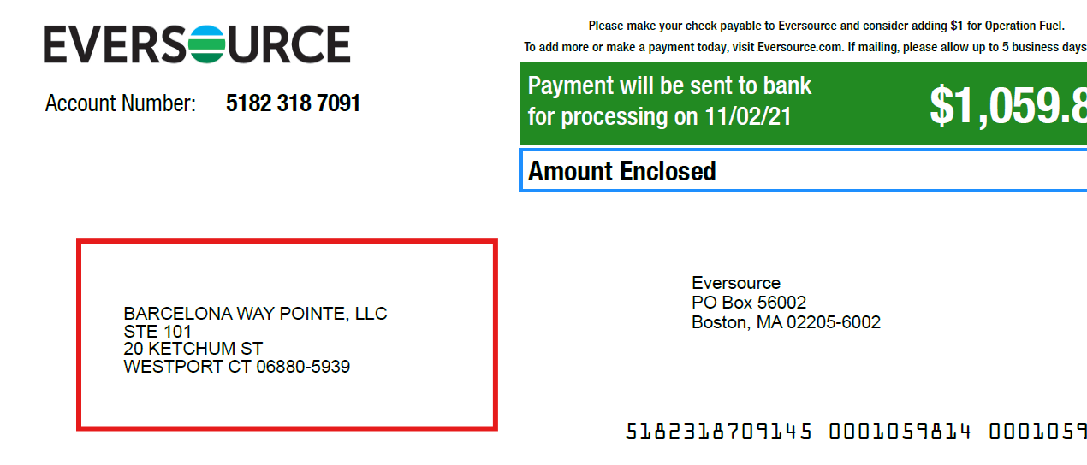

1. Customer DBA Name:

**BARCELONA WAY POINTE, LLC**

1. Account Number

**5182 318 7091**

1. Meter Number(s)

**893884752**

1. Rate Class

**030**

**Source:**

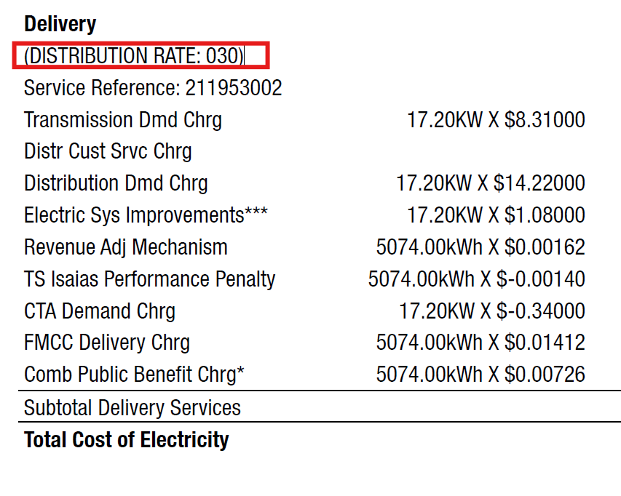

1. Unit (kWh, Therms, CCF, MMBTU)

**KWh**

**Example 5 (Sample Bill)**

1. 12-month or 13-month historical usage

|  |  |
| --- | --- |
| **Month-Year** | **Usage (kWh)** |
| Nov 2022 | 9885 |
| Dec 2022 | 11008 |
| Jan 2023 | 10462 |
| Feb 2023 | 10680 |
| Mar 2023 | 10501 |
| Apr 2023 | 10376 |
| May 2023 | 9842 |
| Jun 2023 | 9910 |
| Jul 2023 | 10727 |
| Aug 2023 | 10697 |
| Sep 2023 | 10378 |
| Oct 2023 | 10607 |
| Nov 2023 | 10412 |

1. Delivery Charge & Rate

**Subtotal Delivery Services: $352.81**

Current Usage: 10412

**Delivery Rate: $0.033885**

1. Tax Charge & Rate

**Subtotal Other Charges or Credits: $395.15**

Current Usage: 10412

**Tax Rate: $0.03795**

1. Supply Charge & Rate

**Subtotal Supplier Services: $624.21**

Current Usage: 10412

**Supply Rate: $0.05995**

1. Current Month’s actual usage

**Current Usage: 10412**

1. Statement Date or “Amount due by” or Invoice Date or Issue Date

**November 15, 2023**

1. Service Address(es)

**Unit 77S, 200 E RANDOLP ST**

1. Customer DBA Name:

**STANDARD PARKING**

1. Account Number(s)

**0434026025**

1. Meter Number(s)

**230010631**

**230110040**

Source:

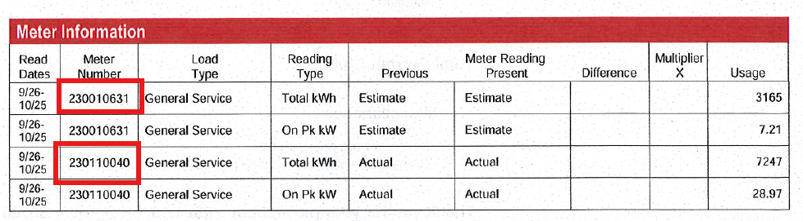

1. Rate Class

**0 to 100 kW**

1. Unit (kWh, Therms, CCF, MMBTU)

**kWh**

**Full Contract Extraction Examples:**

**Example 3 (Contract)**

1. 12-month forecasted usage or entire contract forecasted usage

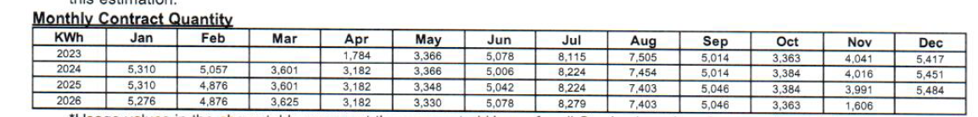

1. Delivery Period or Contract Duration or Contracted Period or Effective Dates

**April 2023 – November 2026.**

Logic: April 01, 2023 + 43 months OR look at the forecasted usage table above.

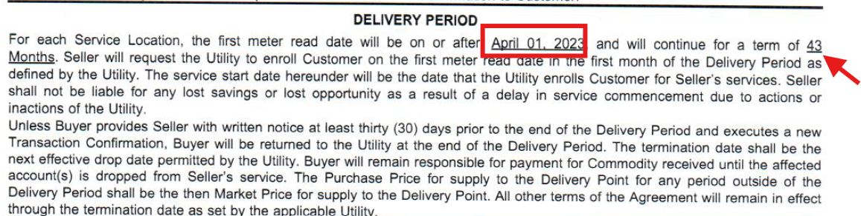

1. Service Address(es)

**20 Ketchum St Unit 101, Westport, CT, 06880**

**Source:**

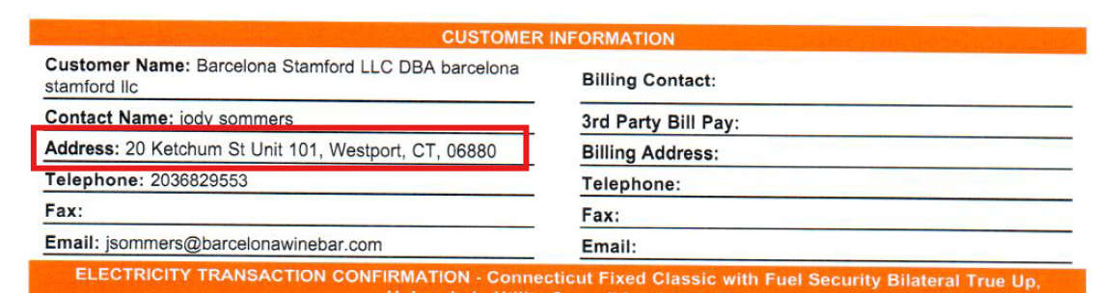

1. Customer DBA Name:

**Barcelona Stamford LLC DBA barcelona stamford llc**

1. Account Number(s)

**51424905065_315681008**

1. Meter Number(s)

N/A

1. Rate Class

**030**

1. Rate(s)

**11.110 (cents/KWh)**

1. Unit (kWh, Therms, CCF, MMBTU)

**kWh**